TCOM 2010-FA20 Summer 2023, Dr. Arnett



Cybersecurity Consulting: Report

To: Noelle Firewalton, Chief Information Officer (CIO) at Quantum Solutions

Executive Summary

June 22, 2023

This report provides practical cybersecurity recommendations for Quantum Solutions, a company seeking to improve network traffic monitoring and protect against cyber adversaries. We have conducted extensive research to offer solutions that are the most practical approaches to this matter.

Our recommendations focus on essential cybersecurity practices, including raising awareness about phishing attacks, providing comprehensive SIEM training for employees, ensuring effective firewall implementation, and other basic security measures. By adopting these practices, Quantum Solutions can establish a strong cybersecurity foundation.

We propose an improved phishing awareness program to educate employees about potential risks and equip them with practical strategies to identify and avoid phishing attempts. On top of this, comprehensive SIEM training will teach employees to effectively use the system for monitoring and detecting security threats. Strengthening firewall configuration and management practices will add an extra layer of protection. Finally, we suggest implementing additional security measures such as regular security audits and vulnerability assessments.

This report offers practical cybersecurity recommendations tailored to Quantum Solutions. By implementing these recommendations, Quantum Solutions can enhance its cybersecurity defenses, mitigate the risks associated with network traffic monitoring, and empower employees to actively contribute to a secure environment. We are confident that these measures will foster a culture of cybersecurity awareness and strengthen Quantum Solutions' overall security posture.

Table of Contents

Statement of Purpose: 4

Statement of Problem and Context: 4

Objectives: 5

Methodology: 5

Preventing Phishing Attacks 6

Employee Training on SIEM Usage 6

Ensuring Firewall Implementation 6

Other Basic Security Measures 6

Current Network Traffic Monitoring Practices: 7

Identified Issues and Vulnerabilities: 7

Improved Phishing Awareness Program: 8

Comprehensive SIEM Training for Employees: 8

Strengthening Firewall Configuration and Management: 8

Implementation of Additional Security Measures: 8

Cost-Benefit Analysis: 9

Implementation Timeline: 9

Resource Requirements: 9

Introduction

# Statement of Purpose:

The purpose of this report is to aid Quantum Solutions with their security concerns. Quantum Solutions is a company who has had issues with their employees clicking malicious links, causing cybersecurity issues. These issues include loss of control of devices, as well as data leaks. As cybersecurity consultants, it is our job to consult our knowledge to Quantum to secure their infrastructure by teaching how to monitor network traffic and other basic security implementations.

# Statement of Problem and Context:

Within this context, the importance of robust cybersecurity practices cannot be overstated. Cyber threats are becoming increasingly sophisticated, exploiting vulnerabilities, and putting organizations at constant risk. Quantum Solutions must strengthen its cybersecurity posture to defend against these threats. Our mission is to provide practical recommendations that align with common industry best practices, enabling Quantum Solutions to enhance its security measures.



Objectives and Methodology

# University attempts to combat scam emails, students remain especially vulnerable - The Daily Gamecock at University of South Carolina

# Objectives:

1. Address network traffic monitoring challenges and provide security recommendations.
2. Identify vulnerabilities and consequences of phishing attacks.
3. Improve network traffic monitoring and mitigate risks.
4. Enhance cybersecurity awareness and safeguard the network.

# Methodology:

1. Review policies, procedures, and technical documentation.
2. Analyze industry best practices and case studies.
3. Consult cybersecurity experts for recommendations.
4. Assess costs, benefits, and practicality.

Cybersecurity Overview

# Preventing Phishing Attacks

The best actions to take to prevent phishing attacks is to protect your personal information. Also keep passwords strong and updated frequently. Obtaining personal information is often the cause of phishing attacks. Password protection is crucial to your system's security as well as your own personal protection.

# Employee Training on SIEM Usage

Using SIEM tools to monitor data in your system is an advantage so security teams can detect a possible threat to your network. These tools typically include log management, event correlation, and incident monitoring to better provide security to your system. Utilizing management tools is a way to stay a step ahead of cybersecurity threats.

# Ensuring Firewall Implementation

Firewalls should remain connected to a network to ensure its protection. The performance of the firewall should be optimal during employee usage. The firewall should not interfere with any user applications. It should also manage data usage to comply with company policies.

# Other Basic Security Measures

Maintaining good practices within the workplace like not sharing any external hard drives or plugging in personal devices such as phones or laptops that could be a concern for cyber security. Keep data protected and report any suspicious activity, like non-company emails, to your IT department.



Network Trafficking and Monitoring Challenges

# Current Network Traffic Monitoring Practices:

* Network Device Monitoring
* Server Monitoring
* Alarms and Notifications
* Hardware Monitoring
* User Specific Dashboards

# Identified Issues and Vulnerabilities:

* Lack of network visibility
* Monitoring performance
* Planning network growth
* Configuration Management
* Access to remote sites

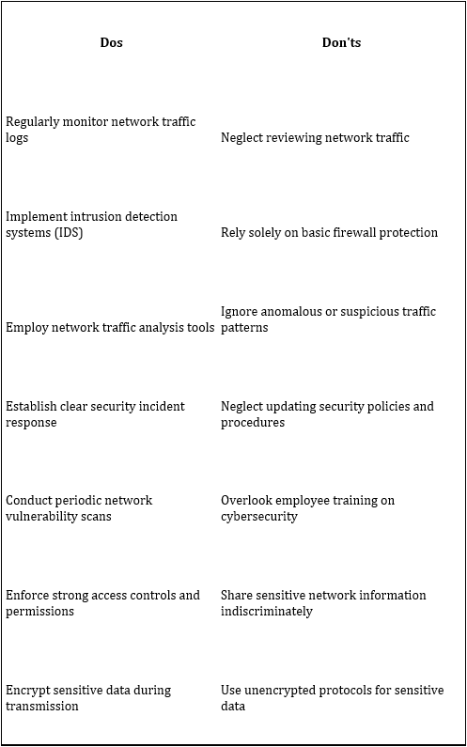

Recommended Solutions

# Improved Phishing Awareness Program:

Phishing is a deceptive practice implemented by scammers and hackers to retrieve personal information. This includes emails, passwords, and payment information. Often, the perpetrators reach out to customers posing as an extension of the company. To help prevent and identify this kind of activity, we suggest requiring employees to complete an awareness program or obtain a certification. CyberconIQ offers an accredited training module, it can be accessed at a very affordable cost, and it also offers free demos.

# Comprehensive SIEM Training for Employees:

SIEM systems effectively provide an accurate overview of a company’s IT system. By implementing this, you can efficiently monitor many things, from end-user devices to intrusion prevention systems. To have this in place, employees must receive the proper training or certifications. There are many resources for this, both paid and free options.

# Strengthening Firewall Configuration and Management:

When assessing the strength of your company’s firewall, you must consider the following: connectivity, performance, and most importantly security. For your firewall to reach its maximum strength, it must perform well during peak user traffic. In addition, the firewall should be subjected to regular testing where the objective is to find any vulnerabilities and gaps. There are many ways to assess this, but we suggest using two specific assessments: threat and vulnerability testing, and penetration testing.

# Implementation of Additional Security Measures:

Additional security measures include but are not limited to the following:

* Securing Wi-Fi networks
* Limiting employee access to data and information
* Unique Passwords and authentication

Feasibility Analysis

# Cost-Benefit Analysis:

1. Evaluate the initial costs of implementing hardware, software, and training.
2. Consider the potential long-term savings from preventing security incidents and data breaches.
3. Assess if the proposed solutions are financially viable for the company.
4. Analyze the potential benefits and how long it will take to recover the investments.

# Implementation Timeline:

1. Identify important milestones and tasks needed for successful implementation.
2. Address potential challenges and risks that may affect the timeline.
3. Consider the availability of resources and any potential disruptions to ongoing operations.
4. Coordinate with external vendors or partners, if required, to ensure timely execution.

# Resource Requirements:

1. The specific skills and expertise needed for successful implementation.
2. Evaluate the availability of internal resources and determine if external support is necessary.
3. Check if the proposed solutions can work with the company's existing technology and infrastructure.
4. Determine if any upgrades or changes are needed.

Conclusion

This report has provided practical cybersecurity recommendations tailored to Quantum Solutions in their efforts to enhance network traffic monitoring and protect against the risks associated with phishing attacks. By adopting the proposed solutions, Quantum Solutions can establish a strong cybersecurity foundation and mitigate the vulnerabilities posed by employees clicking malicious links. The recommendations outlined in this report emphasize essential security measures. These measures, when implemented, will contribute to a culture of cybersecurity awareness within the organization and strengthen Quantum Solutions' overall security posture.

The improved phishing awareness program will equip employees with the knowledge and strategies needed to identify and avoid phishing attempts, reducing the risk of data breaches and loss of control over devices. Additionally, comprehensive SIEM training will enable employees to effectively monitor and detect security threats, enhancing network traffic monitoring capabilities. By strengthening firewall configuration and management practices, Quantum Solutions can add an extra layer of protection to their network infrastructure, safeguarding against unauthorized access and potential breaches. Furthermore, the implementation of additional security measures such as regular security audits and vulnerability assessments will help identify and address potential weaknesses, ensuring ongoing protection.

By implementing the cybersecurity recommendations provided in this report, Quantum Solutions can enhance its cybersecurity defenses, mitigate network traffic monitoring risks, and empower employees to actively contribute to a secure environment. These measures will enable Quantum Solutions to establish a resilient cybersecurity posture, safeguarding sensitive data and ensuring the organization's ongoing success in the face of evolving threats.



References

“*Cybersecurity for small businesses*. Federal Communications Commission. (n.d.). <https://www.fcc.gov/communications-business-opportunities/cybersecurity-small-businesses>

*Phishing awareness training & remediation - phishfixiq*. cyberconIQ.com - Human Defense Platform & Advisory Services. (2023, June 7). <https://cyberconiq.com/phishing-awareness-training-and-remediation/?utm_term=phishing+security+awareness&utm_campaign=Search-1&utm_source=adwords&utm_medium=ppc&hsa_acc=8882323785&hsa_cam=19979731141&hsa_grp=149476022833&hsa_ad=655082871575&hsa_src=g&hsa_tgt=kwd-299036976929&hsa_kw=phishing+security+awareness&hsa_mt=b&hsa_net=adwords&hsa_ver=3&gclid=CjwKCAjwhdWkBhBZEiwA1ibLmNjNkLLi3b4976bo8yg-nl2oDAK1t5UrY3jqJx0dwGcQi43rfuB92xoC6xQQAvD_BwE>

RSI Security. (2022a, March 14). *Comprehensive guide to firewall implementation*. RSI Security. <https://blog.rsisecurity.com/comprehensive-guide-to-firewall-implementation/>

(2022, September 19). *How to protect against phishing: 18 tips for spotting a scam*. Norton.com. Retrieved June 23, 2023, from <https://us.norton.com/blog/how-to/how-to-protect-against-phishing>

Microsoft (2023, June 23). *What is SIEM?* Www.Microsoft.com. Retrieved June 23, 2023, from https://www.microsoft.com/en-us/security/business/security-101/what-is-siem

Appendix

<https://scrubbed.net/blog/linkedin-data-leak-what-we-can-do-about-it/>

<https://cardconnect.com/launchpointe/payment-trends/target-data-breach>

<https://jise.org/Volume29/n1/JISEv29n1p11.pdf>

<https://blog.rsisecurity.com/comprehensive-guide-to-firewall-implementation/>

<https://cyberconiq.com/phishing-awareness-training-and-remediation/?utm_term=phishing%20security%20awareness&utm_campaign=Search-1&utm_source=adwords&utm_medium=ppc&hsa_acc=8882323785&hsa_cam=19979731141&hsa_grp=149476022833&hsa_ad=655082871575&hsa_src=g&hsa_tgt=kwd-299036976929&hsa_kw=phishing%20security%20awareness&hsa_mt=b&hsa_net=adwords&hsa_ver=3&gclid=CjwKCAjwhdWkBhBZEiwA1ibLmNjNkLLi3b4976bo8yg-nl2oDAK1t5UrY3jqJx0dwGcQi43rfuB92xoC6xQQAvD_BwE>

[How to protect against phishing: 18 tips for spotting a scam (norton.com)](https://us.norton.com/blog/how-to/how-to-protect-against-phishing)

[What is SIEM? | Microsoft Security](https://www.microsoft.com/en-us/security/business/security-101/what-is-siem)